OOJS Javascript assignment

**Question 1:** **Create a hierarchy of person, employee and developers.**

**Solution:**

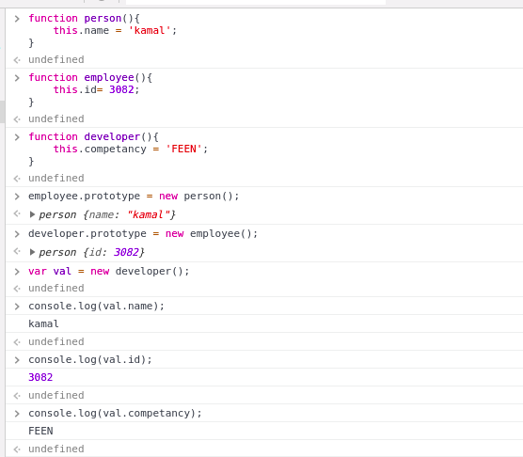

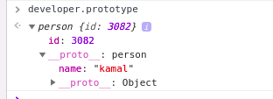

**Question 2: Given an array, say [1,2,3,4,5]. Print each element of an array after 3 secs.**

**Solution:** 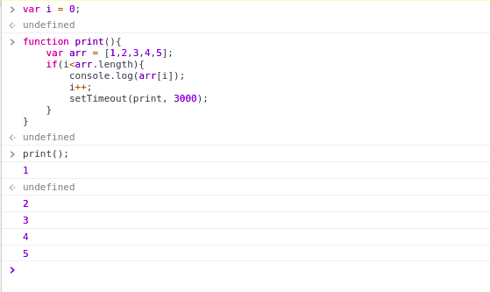

**Question 3: Explain difference between Bind and Call (example).**

**Solution:**

Function bind() is used to create a function, that when called has its this referring to provided value. Bind() makes a function to call several times by creating a new function.

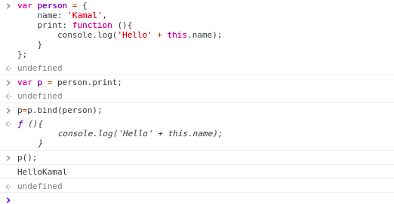

Function call() method calls a function with a given ‘this’ value and arguments provided individually.

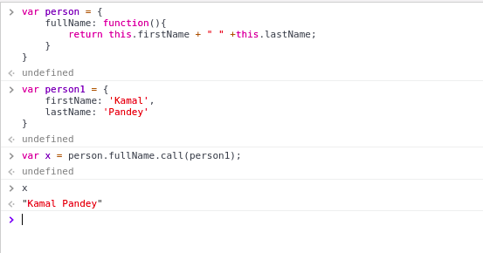

**Question 4: Explain 3 properties of argument object.**

**Solution:**

(1)**argument.length:** The number of arguments that were passed to the function.

(2)**arguments.caller:** Reference to the function that invoked the currently executing function.

(3)**arguments.callee:** Reference to the currently executing function that the arguments belong to.

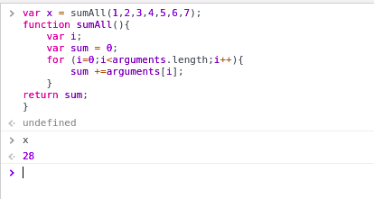

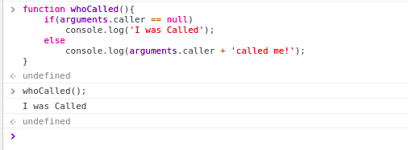

**Question 5: Create a function which returns number of invocations and number of instances of a function.**

**Solution:**

**Number of Invocations:**

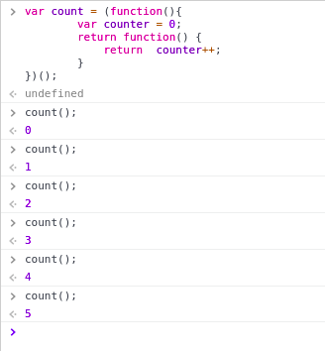

**Number of Instances:**

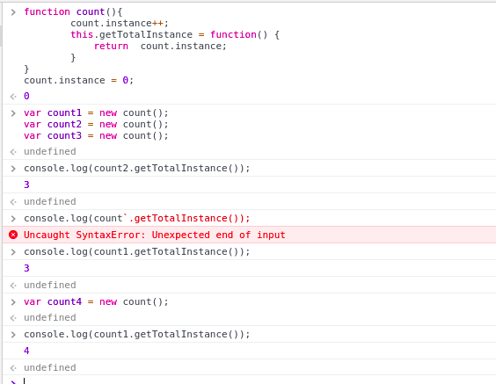

**Question 6: Create a counter using closures.**

**Solution:**



**Problem in Question no.5**

**Question 5: Create a function which returns number of invocations and number of instances of a function.**